All contracts are deployed in AVAX test network

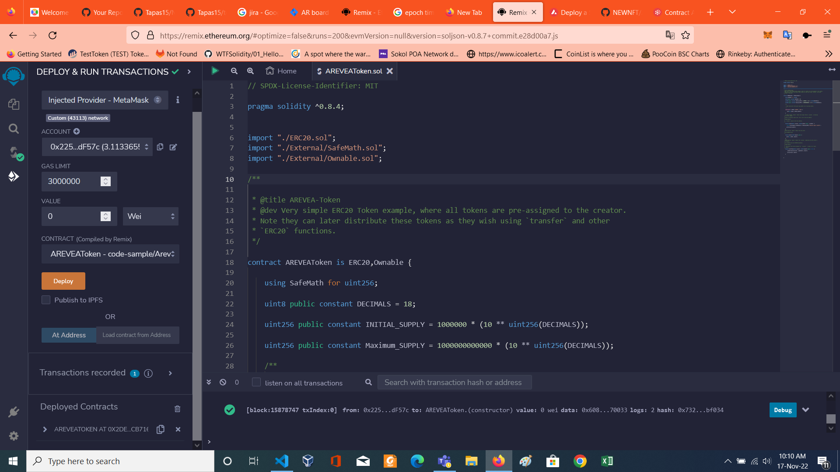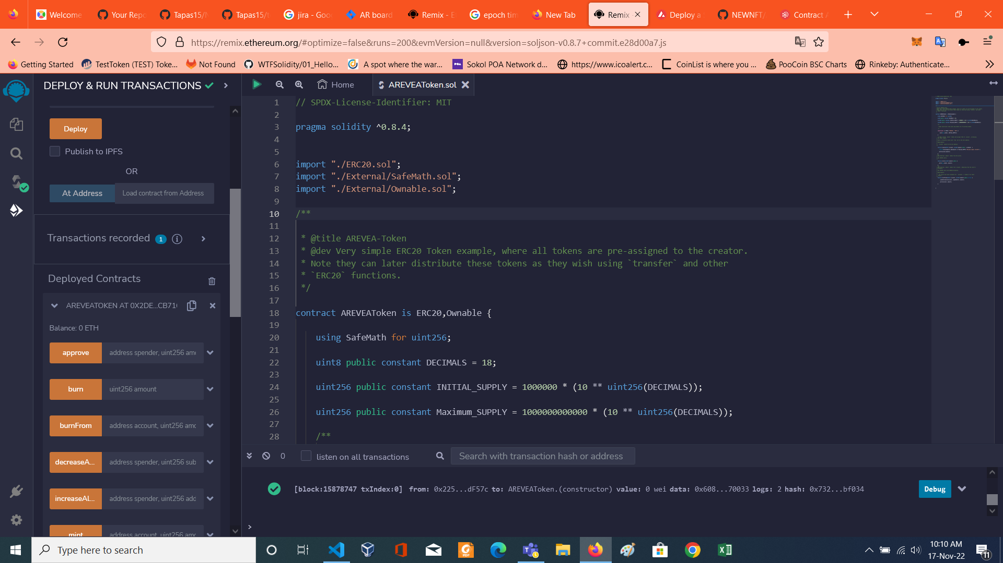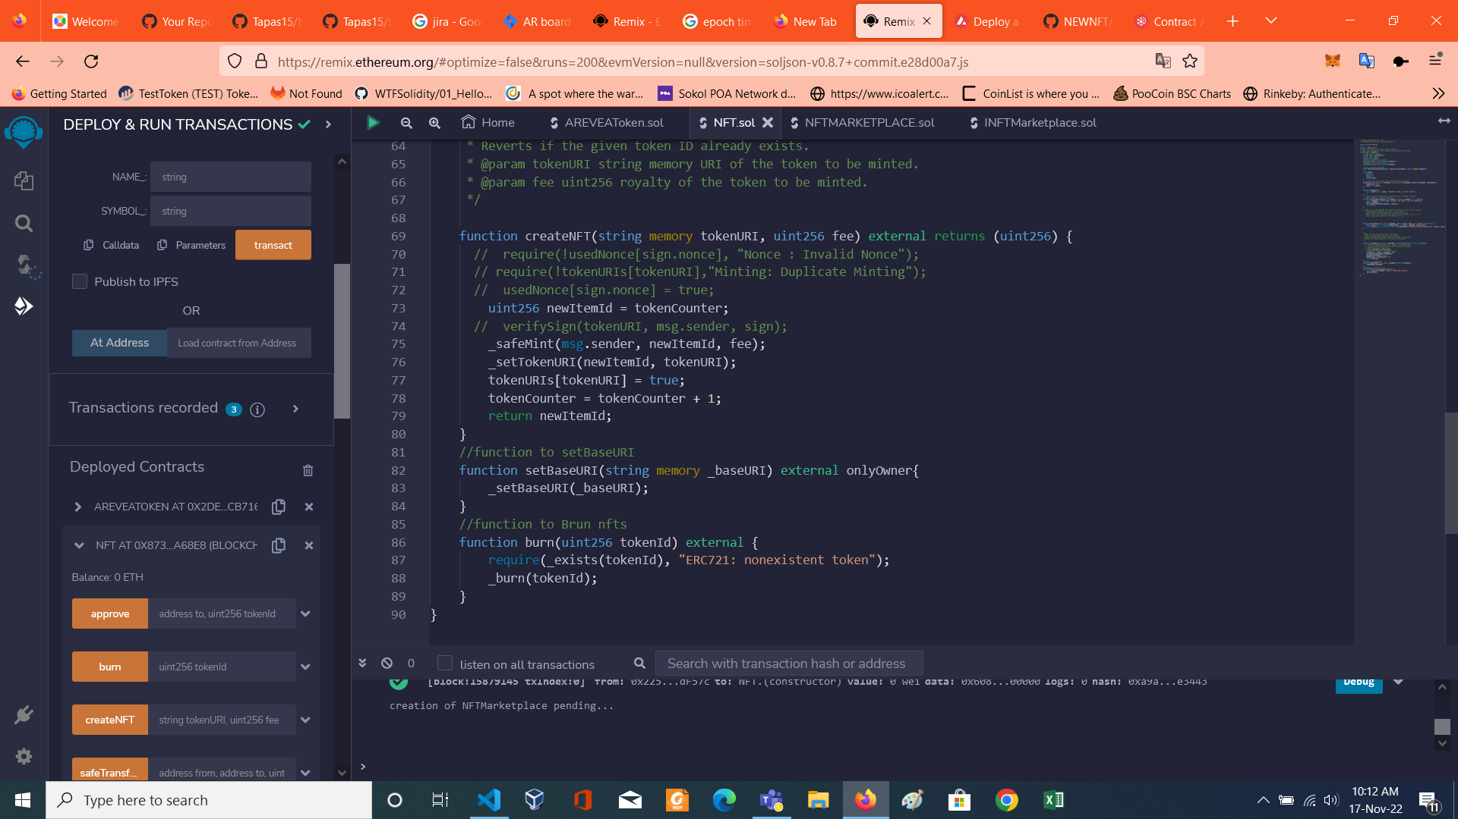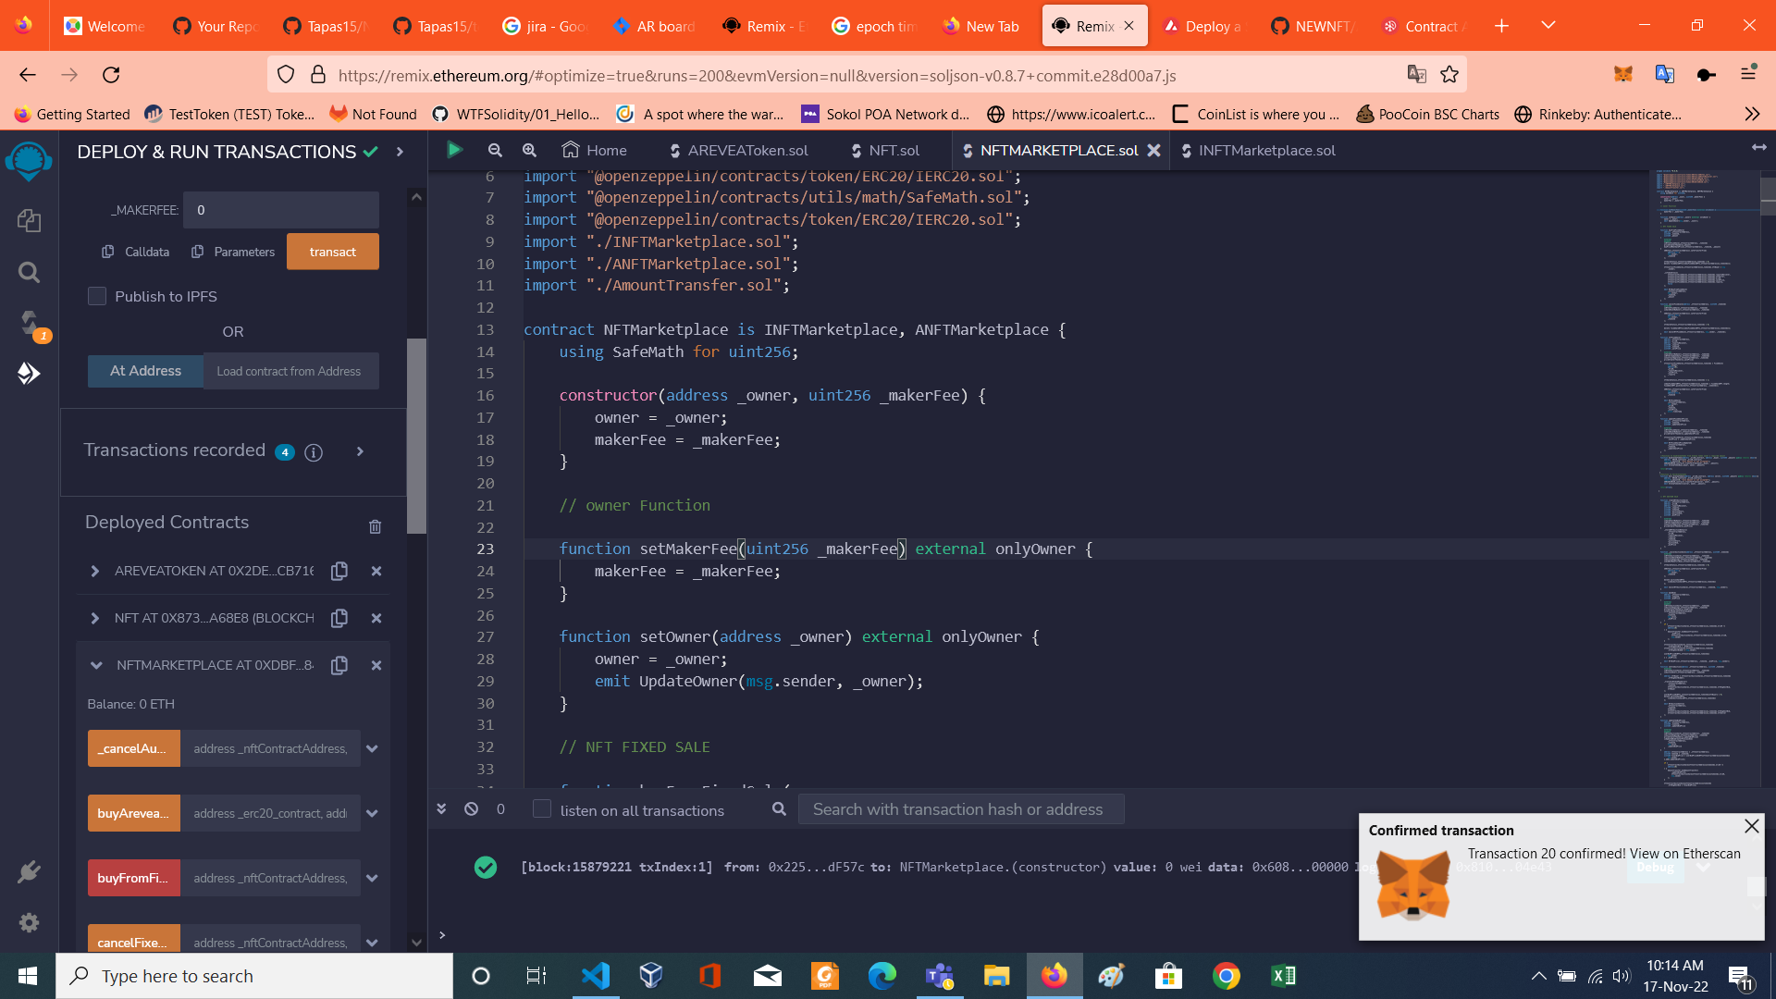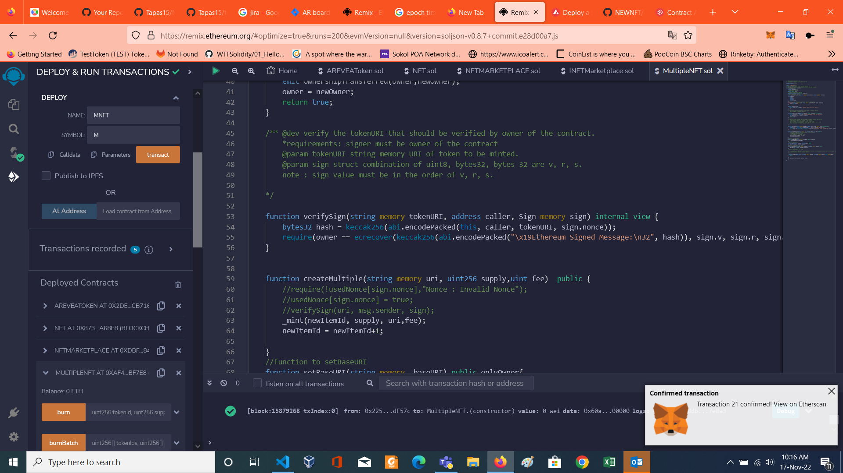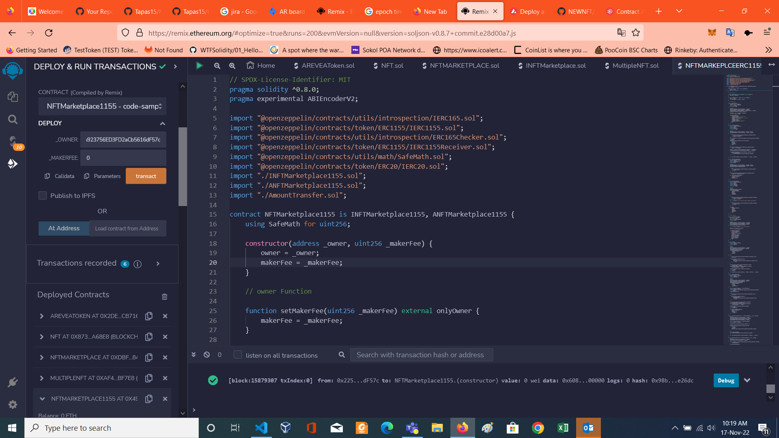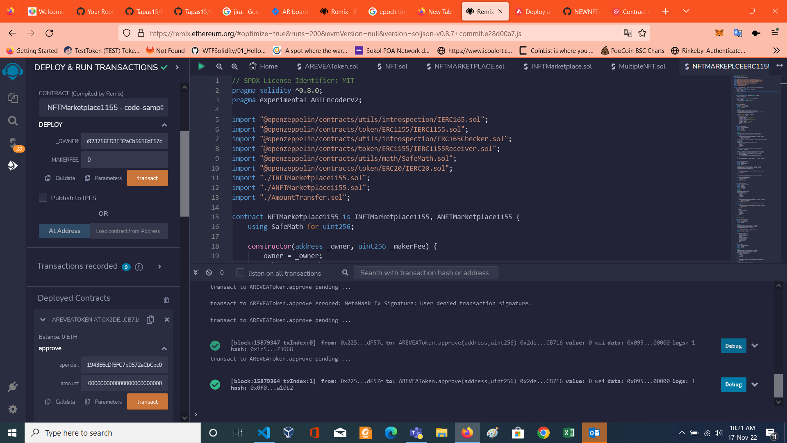

AVAX test net

Test net address of contract

AREVEAToken token 0x2de1cC902c79Ee6CCb6138Fb315846A46BECB716

Single nft 0x87392f90122909B3201A9Dbf88251df1A4dA68E8

Single Market 0xdBfDfA128662bBE5e2eb03E1Fd33E5C0Cc684011

Multi nft 0xAf4cE7aa8fe84aDA55a84A8631F8893EE7Fbf7E8

Multi Market 0x4939E19CDfd09e61943E6cDf5FC7b0572aCbCbc0

Explorer link <https://testnet.snowtrace.io/address/0x2258c5b9c82ff0fa923756ed3fd2acb5616df57c>

Now Approval already given

Testing begins

AREVEAToken token Import this address as it is valid token

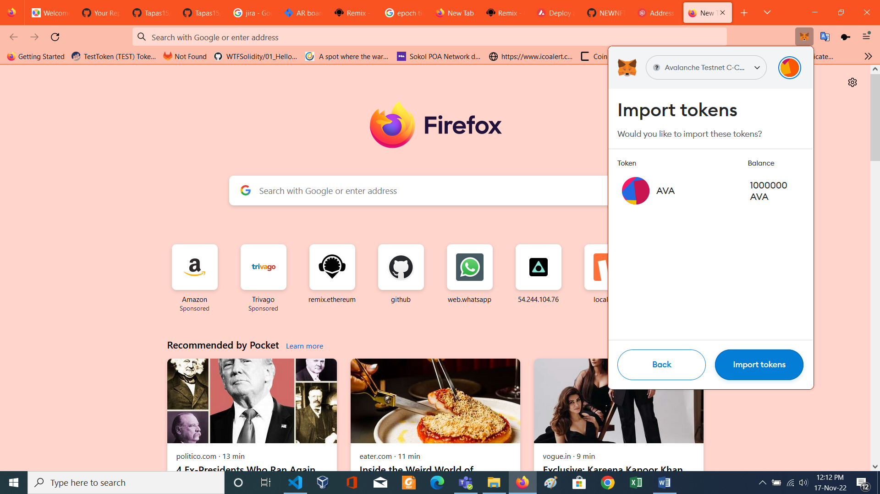

Step 1- sending some ARVEA token to other address

Sending token to second (0xD8D7F4Ce4F23b879Ef1F6f08E73163A6AAe5312b)and 3rd address (0xFecF18f4DEb45581d91DC435504af617E0082223)

Now both account have 100000 ava

Now step 2-create nft and test of fixed sale of nft begins

Sub steps 1 – create a single nft with id 1 with account 2 (0xD8D7F4Ce4F23b879Ef1F6f08E73163A6AAe5312b)

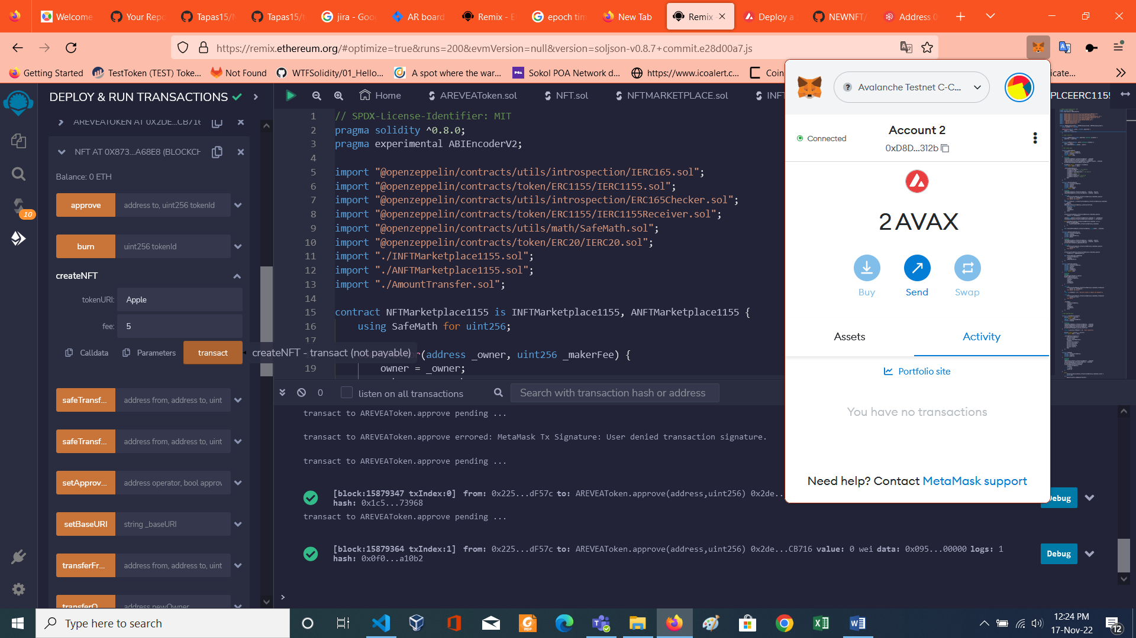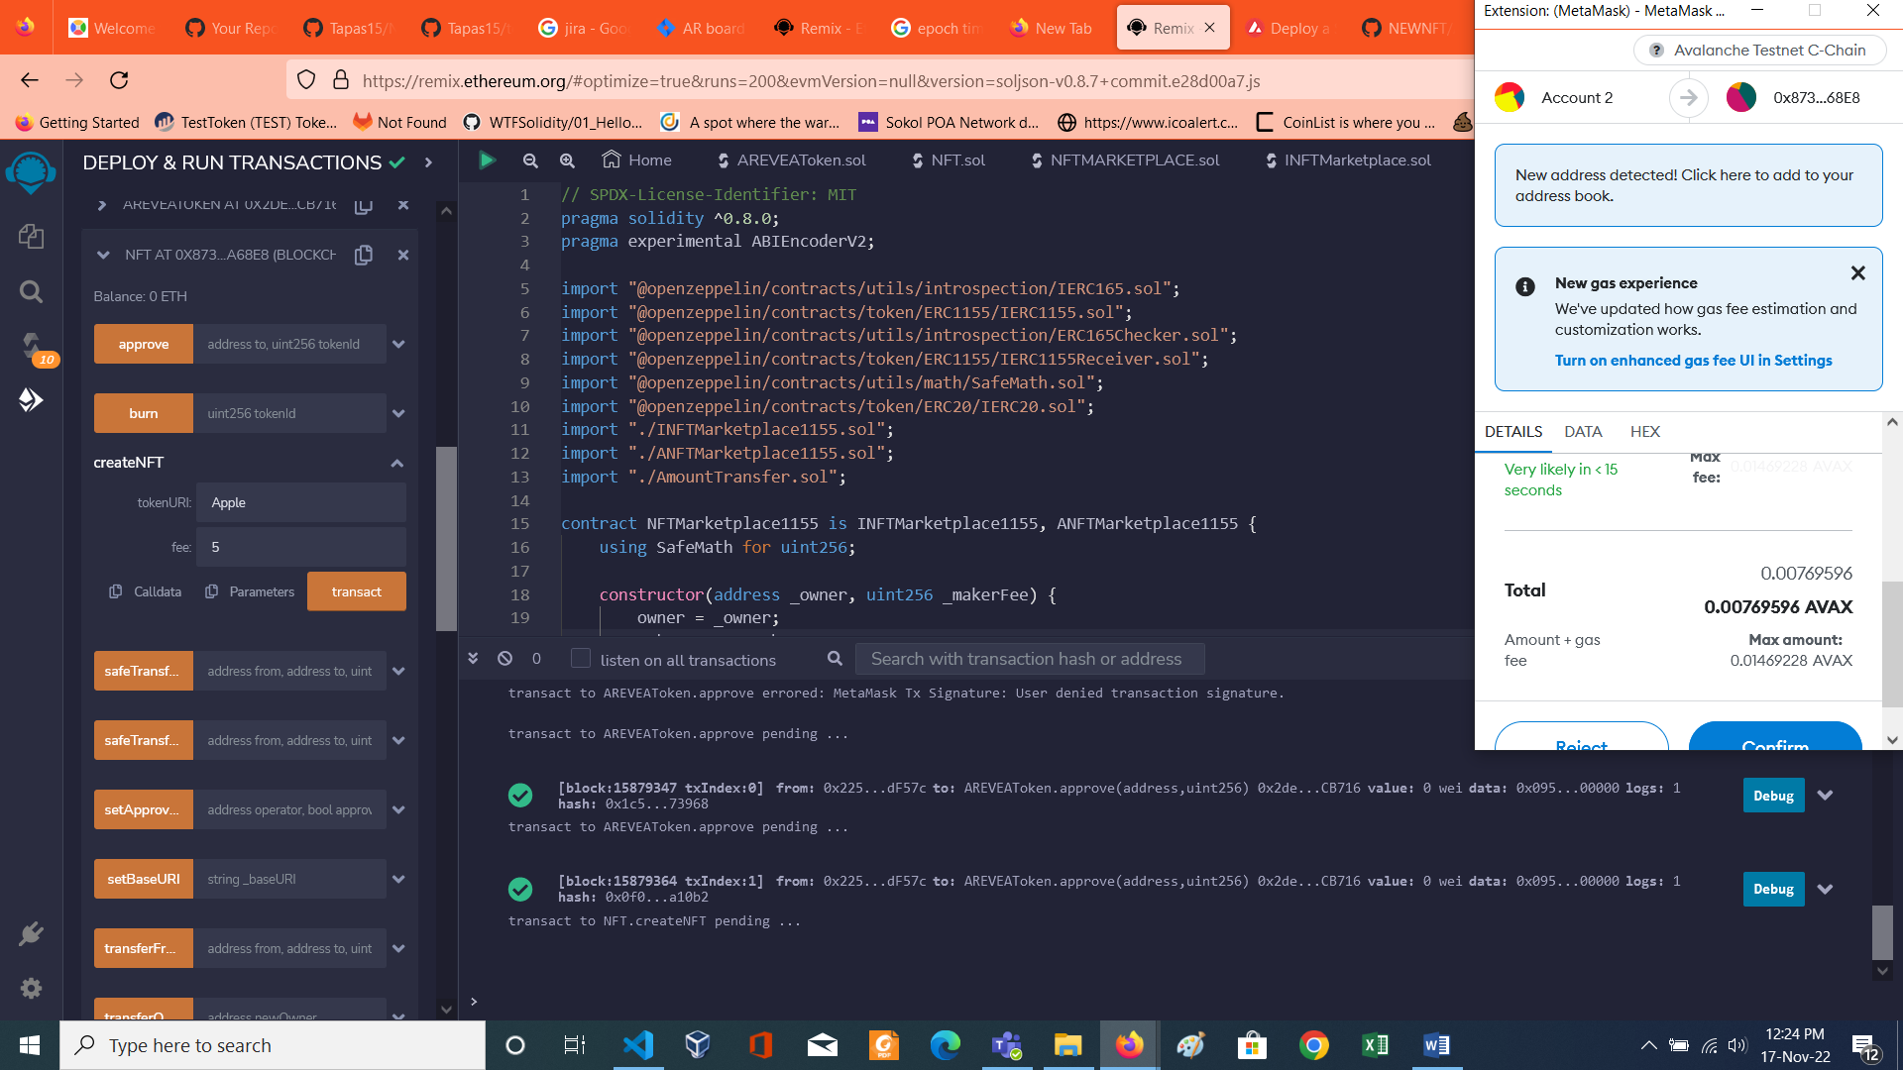

Owner of nft token id 1 is second address

